afname = electricity taken from the grid / demand / consumption 0-3
opwek = electricity produced and fed into the grid / generation 0-3
When is “congested”
Conjestged rule: some times local postcode shows avg_afname_code < 1,
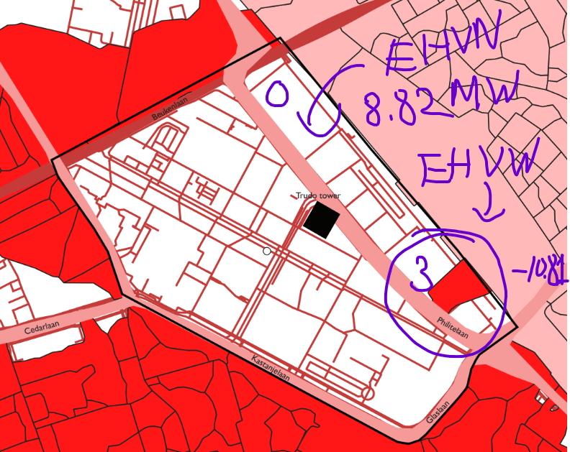
but the larger feeding area still has a problem, such as queue_afname_mw > 0 or utilization_afname_percent >= 90%

Planned grid project:
- EHVN_2027 (2027)
- EHVW_2026 (2026); EHVW_2028 (2028).

With the current data, we cannot see exact remaining capacity for each PC6 5611AS.
We only have remaining capacity at the bigger feeding-area level

Macthing data with buurt Strijd-S
Using buurten, we get exact sape of Strijd-S.
Match close postcode to each neighbourhood
Ex: Strijd-S 5617, takes all PC6 rows in congestie_pc6.csv that start with that postcode: 5617
And sumizse data
- max_afname_code
- avg_afname_code share_af
- name_code_gt0
- main feeding area
The shape of Strijp-S is exact. The congestion value for Strijp-S is estimated from postcode 5617.
- postcode-based neighbourhood approximation
So the data we try to combine just approximation.

Calculate Nominal Grid Capacity
remaining capacity = available afname capacity - needed afname capacity
use congestie_pc6 to get all PC6 in Strijd S, electricity grid area that supplies power are EHVN (25), EHVW (1). So, only look at EHVN
For EHVN, the source data says:
aanwezige_transportcapaciteit_afname = 111,14 MW
needed_transportcapaciteit_afname = 102,3191745576873 MW
= 8.82MW
111.14 – 102 = 8.82

